**LAB NO# 6,7 & 8 (COMBINED)**

**Objectives**: 1) To learn physical DW Design.

2) To learn executing queries in DW.

3) To learn analysing results of DW queries.

**Generate reports using both MDX and Excel Pivot table for the following scenarios:**

**SQL Server:**

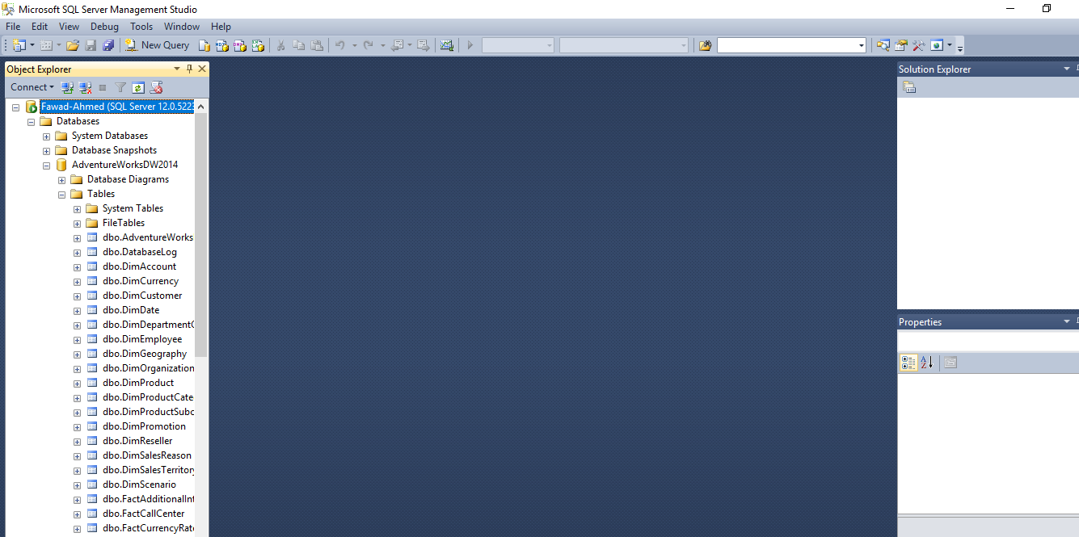

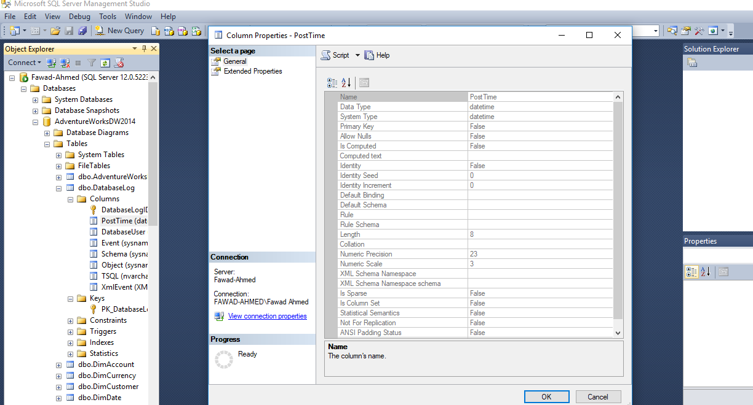

**EXCEL PIVOT TABLE GENERATED**

**Excel Result**

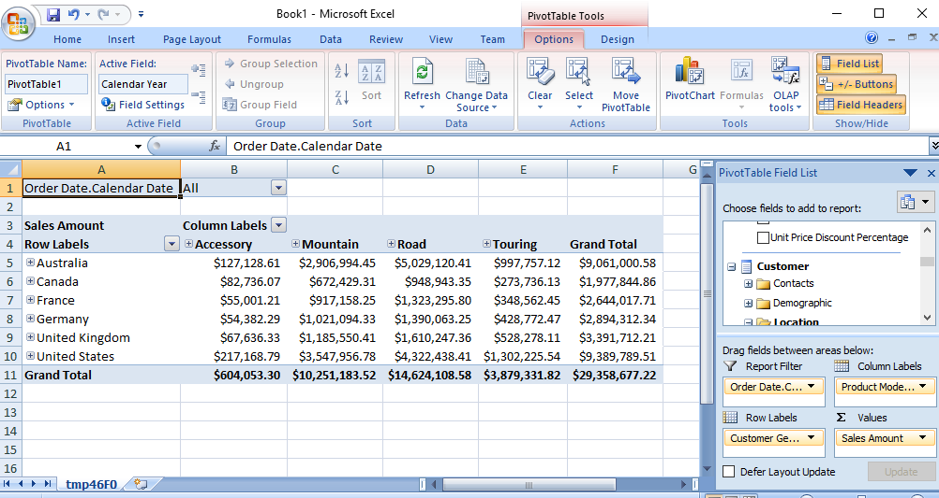

1. Display the standard cost of all the products along with their categories according to the regions in which they were sold. Which region is the most and the least expensive according to the result retrieved?

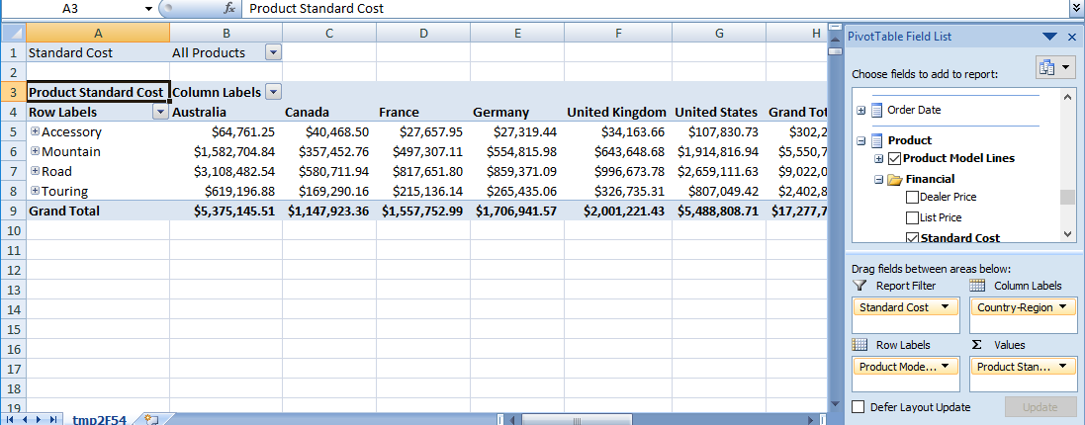

1. Display the Tax amount for customers according to their educations and occupations over calendar year. Do these factors impact the tax amount paid by a customer? Which class of customers pays the highest tax amount?

Ans: Yes, these factor impact on customer you can see in image given Below.

-The Bachelors class pays highest tax amount.

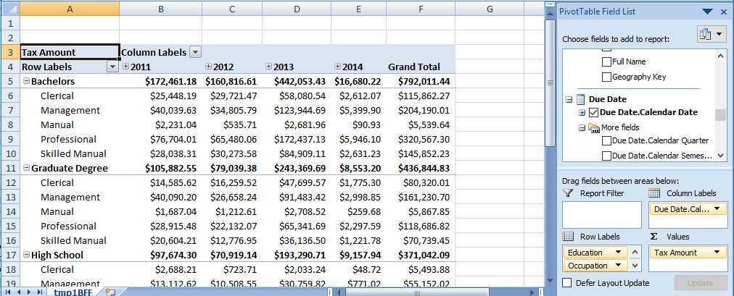

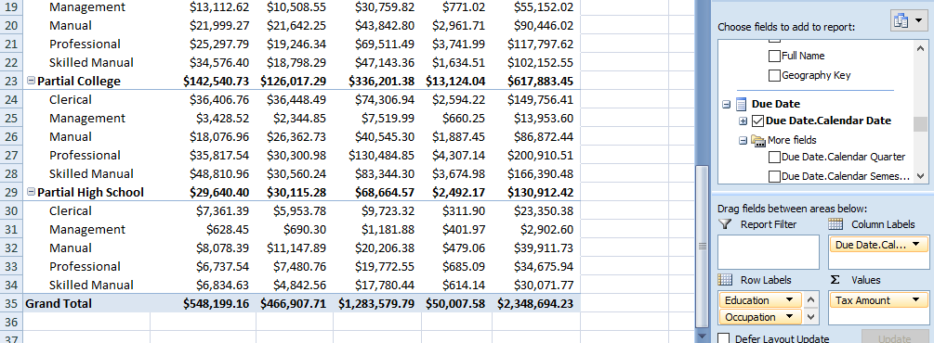

1. Display the sales amount for all products (use product hierarchy) purchased according to the calendar year and filter the results according to the customers’ genders. What type of customers bought the most Biking products?

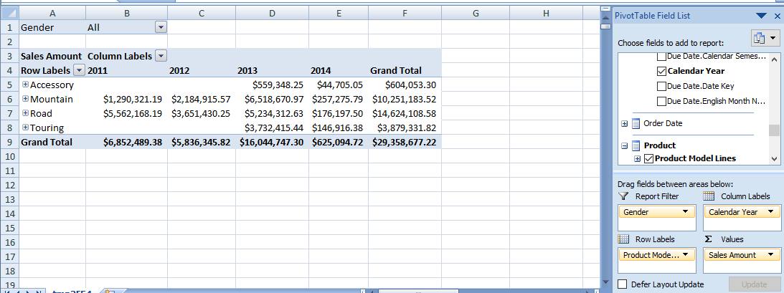

1. Display the order quantity for all the products ordered by customers according to their marital statuses and genders. Filter the results for customers having yearly income greater than or equal to 50,000.

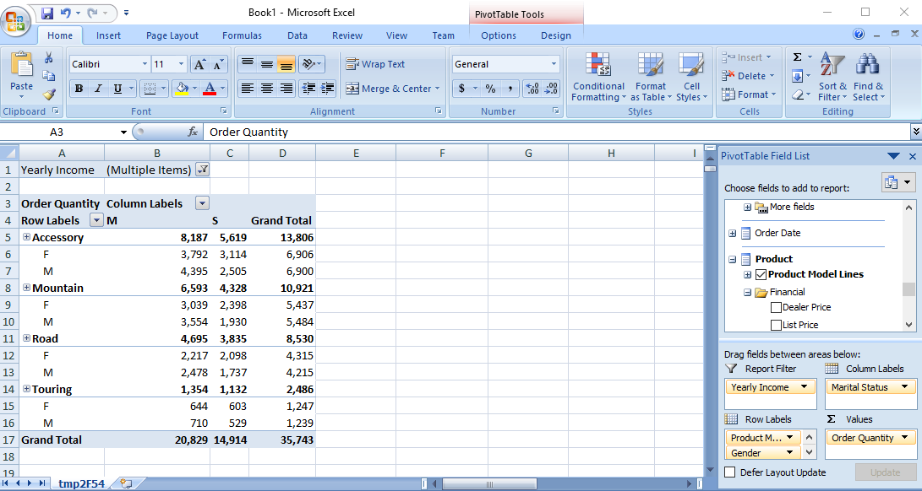

* **Generate reports using MDX**

1. Display the order quantity for all the products ordered by customers according to their marital statuses and genders. Filter the results for customers having yearly income greater than or equal to 50,000.

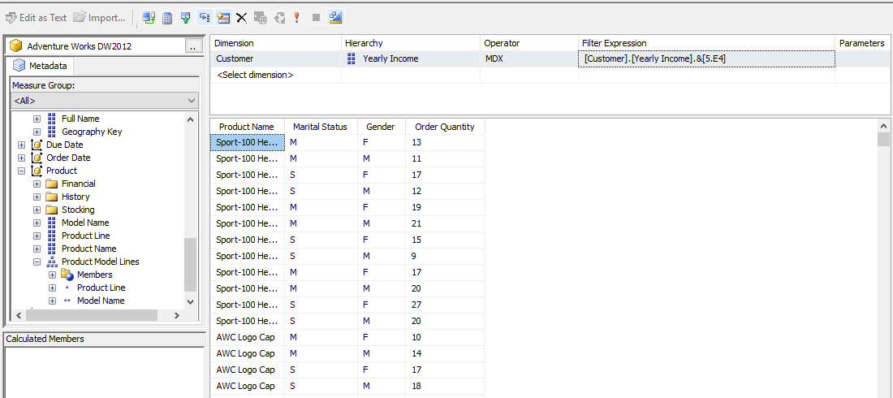

1. Display the Tax amount for customers according to their educations and occupations over calendar year. Do these factors impact the tax amount paid by a customer? Which class of customers pays the highest tax amount?

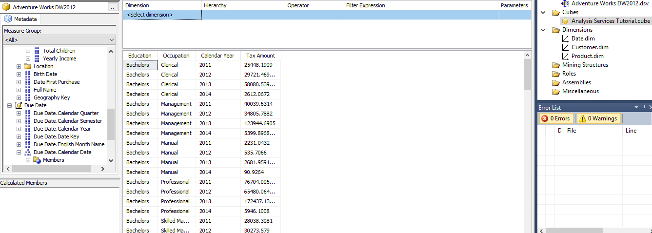

1. Display the sales amount for all products (use product hierarchy) purchased according to the calendar year and filter the results according to the customers’ genders. What type of customers bought the most Biking products?

The Female bought the most biking Products Show In Below Image.

